Deploying Machine learning models with heroku

* What is deployment?
* Process of integrating trained machine learning model into a production environment, usually intended to serve an end-user.

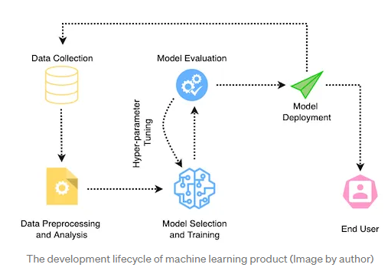

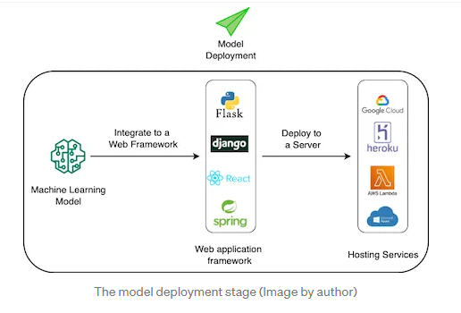

* The three primary steps to deploy a machine learning model are:

1. Develop a machine learning model. This includes gathering of relevant data, analyse it, generating features, selecting models , performing hyper parameter tuning, and finally evaluate the model.
2. Once we are confident about the model, we integrate it into a web application such as Flask, or Django. This involves creating the front-end (user interface) of the application for the user to interact and provide input, and then blending it with backend to feed the obtained data to the machine learning model to make predictions.
3. Deploy the application to a server using hosting services like Heroku, Google cloud etc.

* Steps:

1. Developing the Machine Learning model:

* Generating dummy data points and train linear regression model

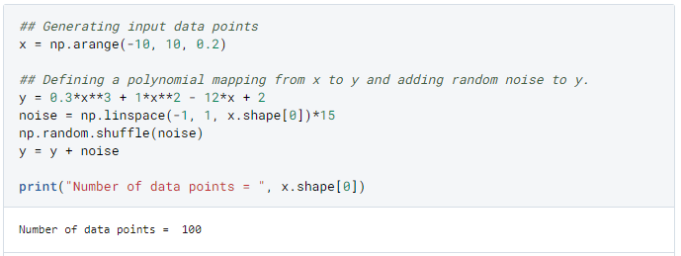

* Training the model

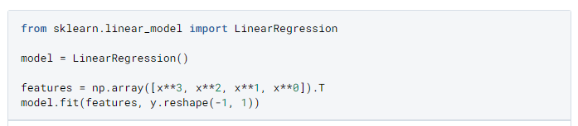

* Saving the model to pickle file

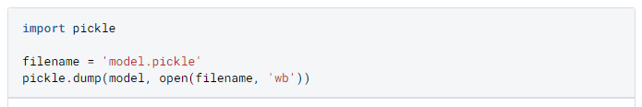

1. Create a Web application using Flask